# *CALL FOR PAPERS*

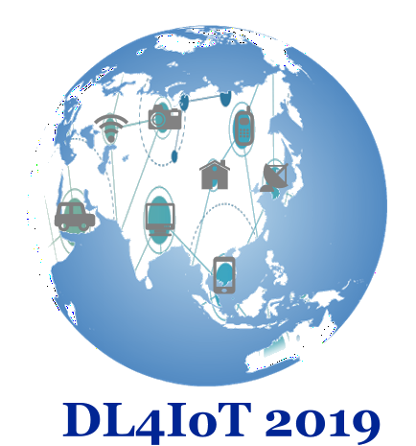

# ****C:\Users\Mina\Desktop\labstic1.png****The 1st Workshop on the Deep Learning for the Internet of Things (DL4IoT)

**Jointly held with**

# Conference on Innovative Trends in Computer Science (CITCS'2019)

**November 20-21, 2019**

**University 8 Mai 1945, Guelma, Algeria**

[**http://www.univ-guelma.dz/seminaires/CITSC-2019/index.html**](http://www.univ-guelma.dz/seminaires/CITSC-2019/index.html)

Internet of Things (IoT) aims at promoting a paradigm according to which everything around us is transformed into a smart thing with the ability of sensing, processing, communicating and/or actuating. Nowadays, IoT technologies are successfully exploited in several domains providing both social and economic benefits. The realization of the full potential of the next-generation Internet of Things still needs further research efforts concerning, especially, the integration of consciousness and awareness in IoT environments. In recent years, deep learning emerges as an embedded processing tool in edge devices such as: mobiles, wearables, and IoT nodes, which will allow a local analysis of data in real time.

The first edition of the DL4IoT Workshop aims at covering state-of-the-art and advancements in technologies, methodologies, and applications for IoT. It encourages the exchange of research knowledge and findings on the design and investigation of deep learning based data Analytics of IoT infrastructures and investigating the challenges posed by the implementation of DL on IoT networking models and services.

Topics of interest include, but are not limited to:

* Modelling, Design, Implementation, and Simulation of IoT Systems
* Internet of Things and Cyber–Physical Systems
* Architectures, Methodologies, and Infrastructures for IoT Systems
* Big Data Analytics and Ambient Intelligence
* Consciousness, Awareness, and Artificial Intelligence in the IoT
* Deep learning and IoT
* Recent trends and advances in DL based IoT
* Deep Learning architecture for IoT security
* Deep Learning experiments, test-beds and prototyping systems for IoT security
* Context-Aware Deep Learning based approaches for IoT
* Activity recognition in a smart home/city using deep learning

# Organizing Committee

## **General chair:**

Pr. Hamid SERIDI (Head of LabSTIC Laboratory, 8 May 1945 Guelma University, Algeria)

## **Workshop Co-Chairs:**

Dr. Ouarda ZEDADRA, LabSTIC Laboratory, 8 may 1945 Guelma University, Algeria

Dr. Karima Benhamza, LabSTIC Laboratory, 8 may 1945 Guelma University, Algeria

**Submission Guidelines**

Authors are invited to submit contributions short papers that did not exceed 4 pages, as well as Technical demonstrations (demos) and posters that do not exceed 2 pages. Contributions should present original unpublished work.

Further information can be found in the workshop Call for Papers at:

<http://www.univ-guelma.dz/seminaires/CITSC-2019/index.html>

**Important Dates**

* Short Papers/ Abstracts Submission: September 15, 2019
* Acceptance Notification: October 15, 2019
* Camera-Ready: October 31, 2019
* Workshop date : 20-21 November, 2019

**Review Process and Publication**

The submissions will be peer reviewed by at least two members of the program committee. The authors of accepted papers or abstracts will have to improve their paper based on reviewers’ comments and will be asked to send a camera-ready version of their manuscripts. At least one author of each accepted work has to register for the workshop, attend the workshop and present his work. Accepted papers will be part of the DL4IoT workshop proceedings.